Invoking EnvironmentConfig from onApplicationStart() method

Sample snippets:
- Invoking EnvironmentConfig - Minimal Configuration
<cffunction name="onApplicationStart" output="false" access="public" returntype="void" hint="">
<cfscript>
var stl = structNew();
stl.oEnvironmentService = '';
stl.stResults = structNew();

stl.oEnvironmentService = createObject( 'component', 'environmentConfig.models.EnvironmentService' ).init();
stl.stResults = stl.oEnvironmentService.configureEnvironment( '/config/environment.xml.cfm' );
application.globalProps = stl.stResults.stProperties;
</cfscript>
</cffunction>

If you dump the application.globalProps variable you should see something similar to the image below:
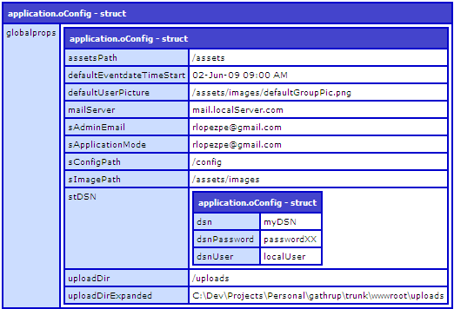
- Invoking EnvironmentConfig - Using Config Bean

<cffunction name="onApplicationStart" output="false" access="public" returntype="void" hint="">
<cfscript>
var stl = structNew();
stl.oEnvironmentService = '';
stl.stResults = structNew();

stl.oEnvironmentService = createObject( 'component', 'environmentConfig.models.EnvironmentService' ).init();
stl.stResults = stl.oEnvironmentService.configureEnvironment( '/config/environment.xml.cfm' );
application.oConfig = createObject('component', 'model.GlobalConfig').init( argumentCollection=stl.stResults.stFlattened );
</cfscript>
</cffunction>
The snippet above loads the Global Config Bean with the properties flattened. To use the normal properties structure, meaning you have not set bUseFlattenedStruct to true in the XML config file, just pass stProperties instead of stFlattened as shown in the line below.
application.oConfig = createObject('component', 'model.GlobalConfig').init( argumentCollection=stl.stResults.stProperties );

If using this configuration, by dumping the application scope you should see something similar to the image below:
